**Name:** Davy Nolan

**Performed:** Friday November 24th,

2017, 14:00 – 16:00 pm

**Date:** 27th November 2017

**Class:** Electrotechnology CS1025

***Laboratory Experiment 3***

**Introduction**

In the first part of the experiment demonstrates a circuit diagram to be constructed. It is critical to understand how to read schematic circuit diagrams and do understand the different symbols. The following circuit consisted of a 2V pk power source, a diode, an 10kΩ resistor and an oscilloscope.

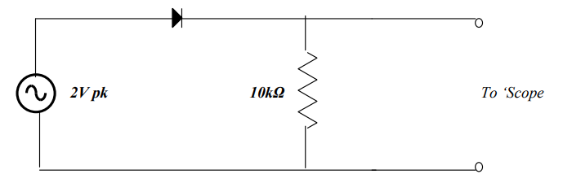 **Diode**

This circuit was to be connected and the output was to be observed and compared on the oscilloscope. The input and output had to be plotted.

In the second part of the experiment, another parallel circuit was connected but with a 1µF capacitor in parallel to the resistor. The supply frequency was set to 200Hz and then to 2KHz and the output was observed on the oscilloscope. The input and output were to be plotted in both cases. The experiment was repeated with a 10µF capacitor.

A capacitor is a passive two-terminal electrical component that stores electrical energy. This is not to be confused as a type battery, as a battery does store energy, this is chemical energy and it is given off in different ways. A capacitor gives bursts of energy and batteries give constant flow. Within the circuit the capacitor’s role is to give energy into the circuit when needed, unlike the resistor it does not dissipate energy.

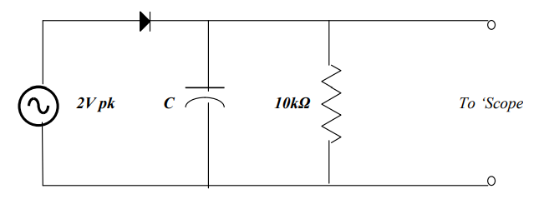 **Capacitor**

**Equipment used:**

**Resistor:** limits and regulates the flow of current in a circuit.

**Diode:** a semi-conductor device with two terminals, they can make a circuit either forward or reverse bias depending on their positioning and direction on the circuit as they only allow current to flow in one direction.

**Voltage function generator:** We used an oscilloscope, this is used to graph the electrical current in the circuit power supply and wires.

**Part 1 explained:**

The circuit is in forward bias, therefore the output on the o’scope is positive. A resistor should always be used in series with a diode as it limits the current and prevents damage to the diode. The diode is in forward bias, so the current can flow from the anode to the cathode. The diode only allows the current to flow in one direction.

**Graphed Results**

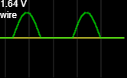

The diode only allows current to flow in one direction and in this case, it is forward bias. The graph rises to the supply voltage of 2V and decreases once the current attempts to flow in reverse bias. The diode flat-lines at 0.7V, allowing no more current to flow until it rises again.

**Part 2 explained:**

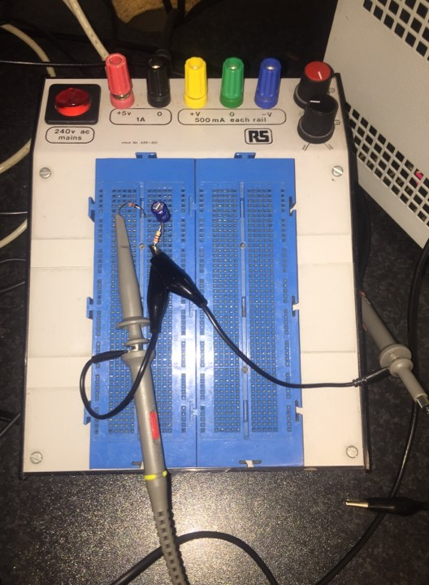This circuit is a parallel circuit but the diode and resistor are still connected in series. A 1µF and a 10µF capacitor were used in 2 separate tests of this part of the experiment. The capacitors appeared to have smoothened the current. When the frequency increased the capacitive reactance decreased.

**Graphed Results**

****The ouput appeared to be a straight line but when the frequency was slowed down, we could see a bump in the line.

The reason for this bump was that the capacitor was supplying electrical energy to let the diode overcome the voltage cut and the reverse bias. The bumps in the line are the bursts of provided energy.

**Conclusion:**

The point of this experiment was to show the effect that a capacitor has on a circuit. The capacitor makes a difference on the circuit and offers a form of resistance.

This experiment also shows that the diode only allows a current to flow in one direction and causes the graph to flat-line whenever the current tries to flow the opposite direction.